AIBS US Office:  2002 Prichard Road  Silver Spring, Maryland,  United States 20902  Email: sudiptaroy.aibs@gmail.com | AIBS Dhaka Center:  52/1, Hasan Holdings (7th Floor),  New Eskaton Road, Ramna,  Dhaka, Bangladesh 1000  Email: rabiuledubd@gmail.com
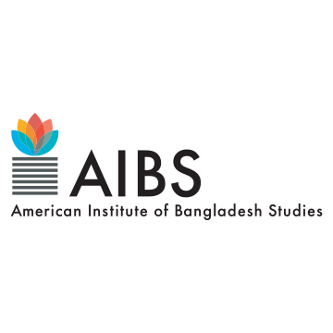

FOR IMMEDIATE RELEASE

AIBS Announces 2024 Fellowships

Silver Spring, MD, May 13, 2024 – The American Institute of Bangladesh Studies (AIBS) has announced the names of the 2024 AIBS Fellows. This year, AIBS has awarded a total of 16 fellowships, including 7 for US citizens and 9 for Bangladeshi citizens. AIBS fellowships are offered in five categories. These are Senior Fellowships, Junior Fellowships, and Pre-dissertation Fellowships for U.S. citizens, and Graduate Student Fellowships, and Professional Development Fellowships for Bangladeshis. AIBS fellowships support exceptional scholars conducting groundbreaking research on issues related to Bangladesh.

US CITIZEN FELLOWSHIPS
Senior Fellowships:
- William Zimmerle, Senior Lecturer, Arts and Humanities, New York University Abu Dhabi.
- Karen Barton, Distinguished Research/Winchester Professor, Geography, GIS, and Sustainability, University of Northern Colorado.
- Kurt Kuehne, Postdoctoral Associate, Social Research and Public Policy, New York University Abu Dhabi.
Junior Fellowships:
- Laura Perez, PhD Candidate, Anthropology, Pennsylvania State University.
- Daniel Adel, PhD Student, Geography and Environment, University of Hawaii at Manoa.
- Devin Creed, PhD Candidate, History, Duke University.
Pre-dissertation Fellowship:
- Tausif Noor, PhD Student, History of Art, University of California, Berkeley.

BANGLADESH CITIZEN FELLOWSHIPS:

Bangladeshi Graduate Student Fellowships:
- Asikunnaby Asikunnaby, PhD Student, Geography, San Diego State University & University of California, Santa Barbara
- Kazi Md Mukitul Islam, PhD Student, Sociology, Boston University
- Muhammad Abdur Raqib, PhD Student, Anthropology, University of California, Irvine
- Poushali Bhattacharjee, PhD Student, Geography, University at Buffalo
- Rafia Rahman, PhD Student, Anthropology, University at Albany, SUNY
- Tasfia Tasnim, PhD Student, Environmental Studies, SUNY College of Environmental Science and Forestry
- Ummul Muhseneen, PhD Student, Department of History, University of South Florida, Tampa

Professional Development Fellowships for Bangladeshi Scholars:
- Sabreena Ahmed, Associate Professor, English and Humanities, Brac University
Host Institution: Department of Educational Leadership and Policy Studies, University of Tennessee at Knoxville
- Ferowza Swapnil, Chief Teaching Fellow (Lecturer) and Program Coordinator, Graduate School of Education, Asian University for Women
Host Institution: School of Education, Johns Hopkins University

AIBS President Professor Ali Riaz emphasized the significance of these fellowships, stating, "These fellowships will play an instrumental role in continuing quality research on Bangladesh. AIBS is the largest single entity in the world that offers the highest number of fellowships dedicated to Bangladesh studies."
The American Institute of Bangladesh Studies (AIBS) is a consortium of American higher education institutions dedicated to fostering scholarly engagement and deeper understanding between the United States and Bangladesh. As the foremost organization promoting Bangladesh studies in the U.S., AIBS supports high-quality research in humanities and social sciences.

For more information about the fellowship program and AIBS, please visit https://aibs.net/fellowships/

For additional details, contact:
Sudipta Roy
American Institute of Bangladesh Studies
Email: sudiptaroy.aibs@gmail.com
Phone: +1 (812) 929-2149

